**Detection of Unmanned Aerial Vehicles (UAV) and Drones**

**Problem statement**

The use of UAV is increasing in every fields. One such use of UAV could be in military to perform tactical operations in battlefield strategy. For security point of view, it is very important to detect UAV because they might be loaded with some type of explosive into them or to stop security and privacy breach. However, real-time detection of UAV has many challenges like protecting the camera from heavy rain, sunlight, and physical damage etc. another challenge might be the distance between the camera and the UAV, if the UAV is too far from viewpoint it would be very difficult for the system to detect the UAV with good accuracy. Similarly flying birds can also create another challenge. Nowadays, Computer Vision and Deep Learning based solutions are becoming popular to detect and track the object. In this research, a novel Faster Regions with Convolutional Neural Network (Faster R-CNN) based object detection method will be exploited for detecting the UAV and drones. One of the challenges in applying CNN based object detection is that, applying such models requires lot of processing power(GPU’s) and time. On successful completion of the project it will deliver the functionality that will enable to detect the UAV and drones.

**Background**

Despite the challenges, in computer vision, UAV detection remains an active research area in recent years. Many methods have been suggested over the years for object detection from image and video. UAV detection has an obvious extension to many applications due to the potential for improving safety and privacy breaches. Traditional object detection methods work by generating different simple binary classifiers using Haar features. Another similar method was using Histogram of Oriented Gradients (HOG) features and Support Vector Machine (SVM) for classification. OverFeat was the first advances in deep learning for the task of object detection. OverFeat proposed a multi-scale sliding window algorithm using Convolutional Neural Networks (CNNs). R-CNN improves 50% results on the object detection challenge. The drawback of R-CNN was that, the training had lots of problems, first we need to generate proposals for the training dataset, apply the CNN feature extraction to every single one then finally train the SVM classifiers.

Fast R-CNN is Like R-CNN, it uses Selective Search to generate object proposals, but instead of extracting all of them independently and using SVM classifiers. The drawback of Fast R-CNN was that the model still relied on Selective Search, which became the bottleneck when using it for inference. Faster R-CNN added what they called a Region Proposal Network (RPN) gives better results than the previously discussed methods for object detection. Faster R-CNN is an attempt to get rid of the Selective Search algorithm and make the model completely trainable end-to-end.

**Methodology**

Architecture of the UAV detection is shown in fig 1.

*Step 1: Data collection and dataset preparation*

This will involve collection of UAV and drone images/videos from available sources.

*Step 2: Developing a CNN based object detection model*

To detect the UAV and drones, a CNN based model will be developed. The model will have convolution layer, RELU and max pooling layer, fully convolutional layer and Softmax activation function. The images from the dataset will be inputted to the convolution layer. A convolution of appropriate size (M x N) will be applied on input image to extract the features and create a feature map. The whole dataset will be divided into training and testing data. The model will be trained by some sample training data and then it will be tested by some test data. The feature extraction will be performed automatically by the model. After training and testing part is over, new input image will be applied and output of the model will be either the image contains the UAV or not. Depending on the accuracy of the result more number of layers will be added or model will be trained against more number of epochs to fine-tune the model. Popular pretrained CNN feature extraction models such VGG16, ResNet or Faster R-CNN shown in fig 2 will be exploited for this task. YOLO (You Only Looks Once) can be another choice, it’s good both at accuracy and speed, outperforming other state-of-the-art detection methods.

*Step 3: Training and experimentation on datasets*

The UAV detection model will be trained on large-scale video datasets populated based on UAV as part of this project.

Faster R-CNN Model

Training and Testing

UAV Dataset

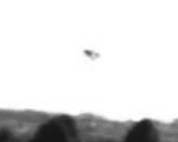

Input Image/Video containing UAV

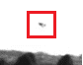

Output: UAV detected in red area

Fig 1. Architecture of UAV Detection

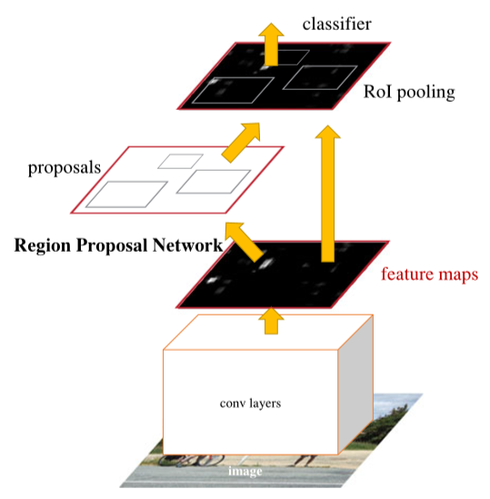

Fig 2. Faster R-CNN Architecture [1]

**Experimental Design**

***Dataset***

The video dataset of UAV and drones can be downloaded from [3]. Dataset will be divided into two parts, training and testing.

***Evaluation Measures***

Measures such as accuracy, Mean Average Precision (mAP), False Negative(FN) and False Positive(FP) along with recall rate, precision-recall curve (PRC), will be computed.

***Software and Hardware Requirements***

For the development and experimentation of the project, Python based Computer Vision and Deep Learning libraries will be exploited. Specifically, libraries such as OpenCV, YOLO (You Only Look Once), TensorFlow will be used. Training will be conducted on NVIDIA GPUs for training the end-to-end version of Faster R-CNN based UAV detection model.

**References**

1. Ren S, He K, Girshick R, Sun J. “*Faster R-CNN: towards real-time object detection with region proposal networks*”. IEEE transactions on pattern analysis and machine intelligence. 2017 Jun 1;39(6):1137-49.]
2. Rozantsev A, Lepetit V, Fua P. “*Flying objects detection from a single moving camera*”. In Proceedings of the IEEE Conference on Computer Vision and Pattern Recognition 2015 (No. EPFL-CONF-206719, pp. 4128-4136).
3. <https://drive.switch.ch/index.php/s/3b3bdbd6f8fb61e05d8b0560667ea992?path=%2Fvideos>
4. Chu Y, Cao G, Hayat H. “*Change Detection of Remote Sensing Image Based on Deep Neural Networks*”.